**Data Engineering Challenge – Ernesto Rountri**

## Exercise 1: Loading Data

*Programmatically (Using Python/R or other programming language) retrieve JSON data from europe.eu (link below) and load the data to a PostgreSQL Database (install it locally).*

*Data source 1: Covid Data:* [*https://www.ecdc.europa.eu/en/publications-data/data-national-14-day-notification-rate-covid-19*](https://www.ecdc.europa.eu/en/publications-data/data-national-14-day-notification-rate-covid-19) *(use the Json file)*

*Load the CSV table Countries of the word.*

*Data source 2: Countries data:* [*https://www.kaggle.com/fernandol/countries-of-the-world/data?select=countries+of+the+world.csv*](https://www.kaggle.com/fernandol/countries-of-the-world/data?select=countries+of+the+world.csv)

*Alternative: Load the data manually (using some importing tool).*

**A: Please refer to the script “Exercise 1” attached on the email.**

## Exercise 2: Create a Pipeline

*Create a Data Pipeline that extracts the last version of the data (Covid-19 data, Data Source 1) and adds to the PostgreSQL database only the new records. (Note the Data source 1, Covid-19 dataset, changes one time per day)*

**A: Please refer to the script “Exercise 2” attached on the email.**

## Exercise 3: Create a View

*Create a view with the data of the table “Countries of the word” with the latest number of cases, “Cumulative_number_for_14_days_of_COVID-19_cases_per_100000” and date when the Information was extracted.*

* **A: The below answers are also included in the “sql script.sql” file.**
* **A: Frist I changed the column names on the countries table:**

ALTER TABLE countries

RENAME COLUMN "Birthrate" TO birthrate;

ALTER TABLE countries

RENAME COLUMN "Deathrate" TO deathrate;

ALTER TABLE countries

RENAME COLUMN "Agriculture" TO agriculture;

ALTER TABLE countries

RENAME COLUMN "Industry" TO industry;

ALTER TABLE countries

RENAME COLUMN "Service" TO service;

ALTER TABLE countries

RENAME COLUMN "Country" TO country;

ALTER TABLE countries

RENAME COLUMN "Region" TO region;

ALTER TABLE countries

RENAME COLUMN "Population" TO population;

ALTER TABLE countries

RENAME COLUMN "Climate" TO climate;

ALTER TABLE countries

RENAME COLUMN pop_density TO pop_density_sq_mi;

ALTER TABLE countries

RENAME COLUMN "Area (sq. mi.)" TO area_sq_mi;

ALTER TABLE countries

RENAME COLUMN "Coastline (coast/area ratio)" TO coastline_ratio;

ALTER TABLE countries

RENAME COLUMN "Net migration" TO net_migration;

ALTER TABLE countries

RENAME COLUMN "Infant mortality (per 1000 births)" TO infant_mortality;

ALTER TABLE countries

RENAME COLUMN "GDP ($ per capita)" TO gdp_percapita;

ALTER TABLE countries

RENAME COLUMN "Literacy (%)" TO literacy_perc;

ALTER TABLE countries

RENAME COLUMN "Phones (per 1000)" TO phones_perthousands;

ALTER TABLE countries

RENAME COLUMN "Arable (%)" TO arable_perc;

ALTER TABLE countries

RENAME COLUMN "Crops (%)" TO crops_perc;

ALTER TABLE countries

RENAME COLUMN "Other (%)" TO other_perc;

* **A: Removed the space at the end of the country name in the contry column in the countries database.**

UPDATE countries

SET country = RTRIM(country);

* **A: Created a new column to store the first day of the year-week in date format, as these were stored as text.**

ALTER TABLE covid_data

ADD COLUMN year_week_date date;

UPDATE covid_data

SET year_week_date = TO_DATE(year_week, 'IYYY-IW');

* **A: Create view query:**

CREATE VIEW covid_cases_per_country AS

SELECT

c.country, c.region, c.population, c.area_sq_mi,

c.pop_density_sq_mi, c.coastline_ratio,

c.net_migration, c.infant_mortality,

c.gdp_percapita, c.literacy_perc, c.phones_perthousands, c.arable_perc,

c.crops_perc, c.other_perc, c.climate, c.birthrate, c.deathrate,

c.agriculture, c.industry, c.service, o.weekly_count,

SUM (o.cumulative_count) OVER (

ORDER BY year_week_date

ROWS BETWEEN 1 PRECEDING AND CURRENT ROW

) AS cumulative_number_for_14_days_of_COVID_19_cases_per_100000,

o.year_week, o.year_week_date

FROM

countries c

JOIN

covid_data o

ON

c.country = o.country

WHERE

o.indicator = 'cases'

ORDER BY year_week_date;

## Exercise 4: Queries

1. *What is the country with the highest number of Covid-19 cases per 100 000 Habitants at 31/07/2020?*

|  |  |
| --- | --- |
| country | total_cases_per_100k_hab |
| Spain | 5196026 |

* **A: Here I had to further alter the column types to accomplish the exercise. Converted the weekly_count, cumulative_count and pop_density_sq_mi to numeric formats and then I had to recreate the view.**

ALTER TABLE covid_data

ALTER COLUMN weekly_count TYPE integer

ALTER TABLE covid_data

ALTER COLUMN cumulative_count TYPE integer

ALTER TABLE covid_data

ALTER COLUMN pop_density_sq_mi TYPE double precision;

* **A: SELECT query:**

SELECT

country,

SUM(cumulative_number_for_14_days_of_COVID_19_cases_per_100000) AS total_cases_per_100k_hab

FROM covid_cases_per_country

WHERE year_week_date <= '2020-07-27'

GROUP BY country

ORDER BY total_cases_per_100k_hab DESC

LIMIT 1;

**Performance: 46 msec**

1. *What is the top 10 countries with the lowest number of Covid-19 cases per 100 000 Habitants at 31/07/2020?*

|  |  |
| --- | --- |
| country | total_cases_peer_100k_hab |
| Lithuania | 215841 |
| Latvia | 225464 |
| Liechtenstein | 286270 |
| Norway | 380127 |
| Malta | 429302 |
| Iceland | 488494 |
| Finland | 582915 |
| Ireland | 674286 |
| Slovakia | 676019 |
| Estonia | 743503 |

* **A: SELECT query**

SELECT

country,

SUM(cumulative_number_for_14_days_of_COVID_19_cases_per_100000) AS total_cases_per_100k_hab

FROM covid_cases_per_country

WHERE year_week_date <= '2020-07-27'

GROUP BY country

ORDER BY total_cases_per_100k_hab ASC

LIMIT 10;

**Performance: 56 msec**

1. *What is the top 10 countries with the highest number of cases among the top 20 richest countries (by GDP per capita)?*

|  |  |  |
| --- | --- | --- |
| **country** | **total_cases** | **gdp_percapita** |
| France | 40086999 | 27600 |
| Germany | 38437756 | 27600 |
| Italy | 26345573 | 26700 |
| Spain | 13980340 | 22000 |
| Netherlands | 8618815 | 28600 |
| Austria | 6084155 | 30000 |
| Portugal | 5621015 | 18000 |
| Greece | 5405742 | 20000 |
| Belgium | 4803737 | 29100 |
| Denmark | 3105726 | 31100 |

* **A: Query**

WITH top20_gdpcountries AS (

SELECT

country,

SUM(weekly_count) AS total_cases,

MAX(gdp_percapita) as gdp_percapita

FROM covid_cases_per_country

GROUP BY country

ORDER BY gdp_percapita DESC

LIMIT 20

)

SELECT

country,

total_cases,

gdp_percapita

FROM top20_gdpcountries

ORDER BY total_cases DESC

LIMIT 10;

**Performance 70 msec**

1. *List all the regions with the number of cases per million of inhabitants and display information on population density, for 31/07/2020.*

|  |  |  |
| --- | --- | --- |
| **region** | **cases_per_million** | **population_density** |
| WESTERN EUROPE | 19180090 | 3545.1 |
| EASTERN EUROPE | 6149040 | 681.2 |
| BALTICS | 347180 | 119.5 |
| NEAR EAST | 61560 | 84.8 |

* **A: For this query I had to transform the values of the pop_density_sq_mi column as they were comma separated values. I used the following queries to create a new column with the transformed values with “.” as their decimal separator.**

ALTER TABLE countries

ADD COLUMN pop_density_numeric numeric;

UPDATE countries

SET pop_density_numeric = REPLACE(pop_density_sq_mi, ',', '.')::numeric;

ALTER TABLE countries

DROP COLUMN pop_density_sq_mi;

ALTER TABLE countries

RENAME COLUMN pop_density_numeric TO pop_density_sq_mi;

* **A: Now here is the query for the main request:**

SELECT

region,

SUM(cumulative_number_for_14_days_of_covid_19_cases_per_100000) * 10 AS cases_per_million,

SUM (pop_density_sq_mi) AS population_density

FROM

covid_cases_per_country

WHERE

year_week = '2020-31'

GROUP BY

region

ORDER BY

cases_per_million DESC;

**Performance: 36 msec**

1. *Query the data to find duplicated records.*

* **For the covid data table I was able to run two queries using the following considerations:**

1. **A: 1st query includes the columns country, weekly_count, cumulative_count, rate_14_day and year_week. It brings back 532 duplicate rows.**

WITH covid_data_duplicates AS (

SELECT country, weekly_count, cumulative_count, rate_14_day, year_week, COUNT(*) AS duplicate_count

FROM covid_data

GROUP BY country, weekly_count, cumulative_count, rate_14_day, year_week

HAVING COUNT(*) > 1

)

SELECT

SUM(duplicate_count) AS total_duplicates

FROM covid_data_duplicates;

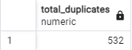

1. **A: 2nd query only considers columns country, weekly_count and year week. It brings back 592 duplicate rows. To which I think is mostly influenced by weekly_counts with null values and some of them with actual duplicate counts for the same week (submitting the same weekly count record more than once). I consider this query to be the most accurate as the other columns: cumulative_count and rate_14_day are derived from the column weekly_count.**

WITH covid_data_duplicates AS (

SELECT country, weekly_count, year_week, COUNT(*) AS duplicate_count

FROM covid_data

GROUP BY country, weekly_count, year_week

HAVING COUNT(*) > 1

)

SELECT

SUM(duplicate_count) AS total_duplicates

FROM covid_data_duplicates;

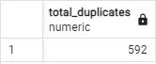

**Performance: 71 msec**

1. *Analyze the performance of all the queries and describes what you see. Get improvements suggestions.*

**A**: By running all the queries, I found that all of them run under 71, but there is always room for improvement. Here are a couple of thinks I can do to improve query performance:

1. Create indexes on the tables referenced by the view covid_cases_per_country. I would create the index on the country column of both the covid_data table and the countries table.
2. I can remove the rows with NULL values in the weekly_count column.

## Exercise 5:

## *Enrich the information with any other piece of data (available on the web) and justify the choice.*

A: I was not able to complete this step, but my inclination is to look for an API that contains the data relevant to my research interests. Once I find such an API, I will proceed to install it and extract the necessary information from the API's response. To do this, I'll map the fields in the API response to match the schema of my dataset, and I'll ensure that I handle the data types correctly during this process. I would use an API for the following reasons:

1. Because an alternative would be to use web scrapping, which takes more effort and time to extract the data. With web scrapping I may need to perform additional data cleaning and transformation.
2. APIs are designed for programmatic data access, making data retrieval more reliable and structured. APIs return data in a structured format as JSON or XML.
3. APIs usually come with detailed documentation.
4. APIs are maintained by the service provider.

## Exercise 6:

## *Produce a report showing the most useful discoveries you have made. Graphical representation is welcome.*

**A**: Countries with lower population density experienced significantly fewer cases per 100,000 inhabitants. This trend can be attributed to the fact that the coronavirus primarily spreads through the air, making transmission more likely among individuals in close proximity.

Many of the countries with low case numbers took proactive measures to contain the virus's spread. These measures included implementing early lockdowns, enforcing social distancing, mandating mask usage, and imposing travel restrictions. However, Spain stood out with a high number of COVID-19 cases per 100,000 inhabitants by the 31st week of 2020.

Spain's population density, with approximately 80 people per square mile, is relatively high compared to countries like Lithuania (55) and Estonia (29.3). Additionally, Spain was dealing with the challenges of a second wave of cases during that period:

*Spain lifted a nationwide state of emergency on June 21 as it emerged from a strict three-month lockdown imposed to gain control over one of Europe’s worst outbreaks. The rapid spread of the virus in Spain left some 28,400 people dead by the official count — almost surely understated — with most of them over the age of 70.*

*https://www.nytimes.com/2020/07/23/world/europe/spain-coronavirus-reopening.html*

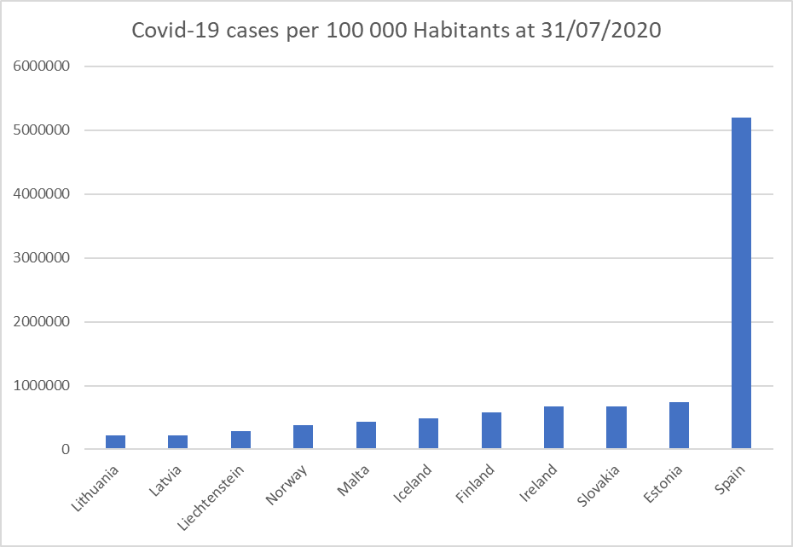

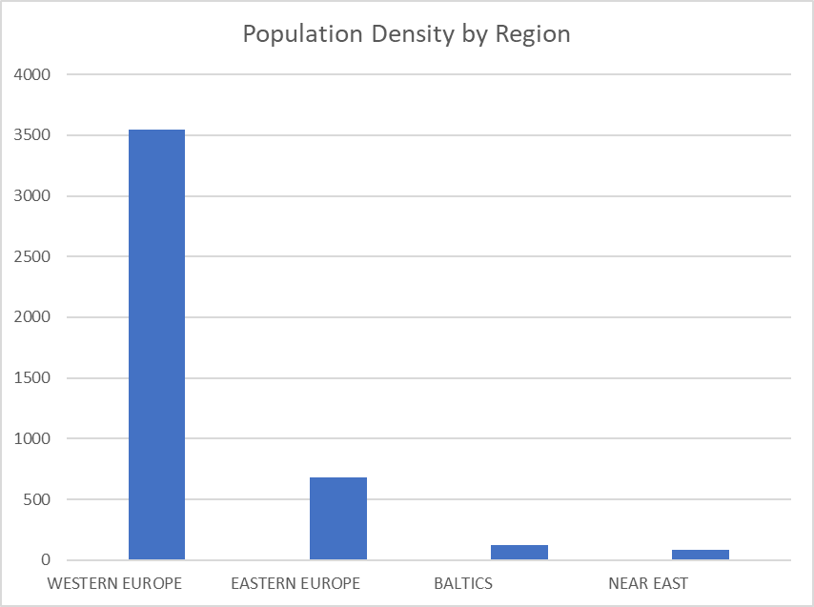

|  |  |  |  |
| --- | --- | --- | --- |
| **Western Europe** | **Eastern Europe** | **Baltics** | **Near East** |
| Liechtenstein  Norway  Iceland  Ireland  Spain  France  Germany  Italy  Netherlands  Austria  Portugal  Belgium  Denmark | Slovakia | Lithuania  Latvia  Estonia | Malta  Finland  Greece |